Financial Aid Appeal
2022- 2023 Academic/Faculty Advisor Progress Overview Form
https://www.mdc.edu/financialaid/important-forms/forms.aspx
Last Name: | First Name: | Middle Initial: | MDConnect Student ID:

ACADEMIC/FACULTY ADVISOR OFFICE USE ONLY
Current Program of Study:
Total Credits required for current Program of Study: |  | Ex:120
Total Credits earned that count toward current Program of Study: |  | Ex: 60
Total number of remaining credits to complete Program of Study: |  | Ex: 60

(Please include applicable comments below)

Include MAP https://my.mdc.edu/

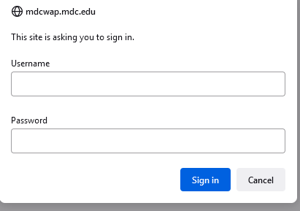
https://man4162group1.weebly.com/uploads/5/4/3/7/54376519/my_planner_example.pdf

Include Degree Audit

Include Registration

